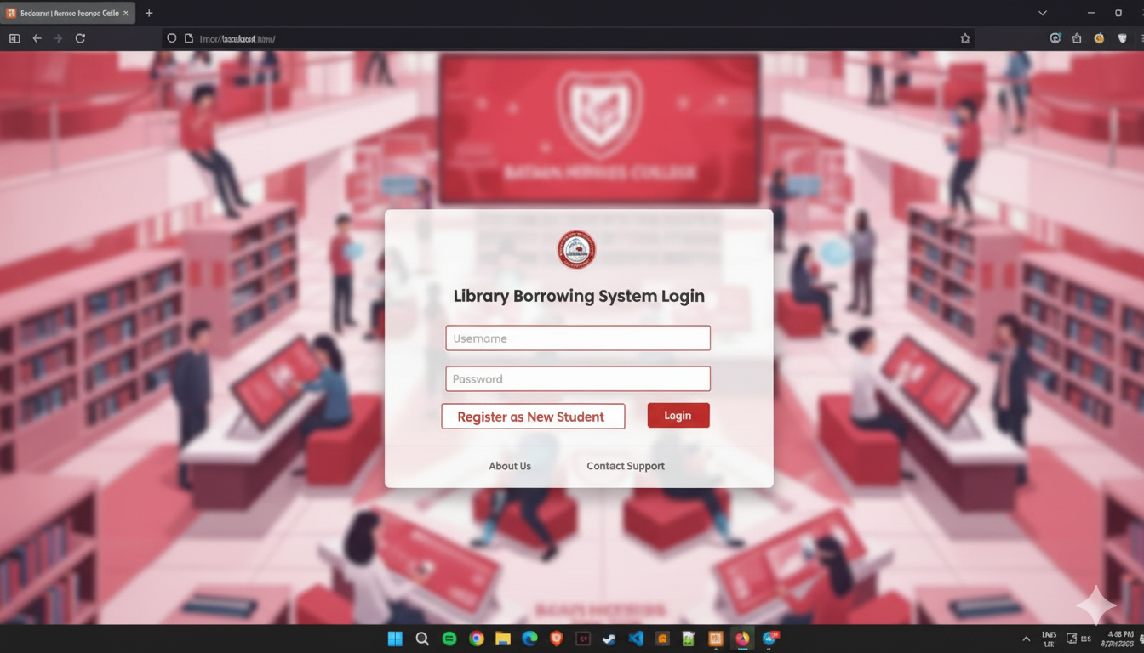

A library borrowing system needs a secure and organized way for students and administrators to access its features. The login module serves as the primary entry point for all users, ensuring that only authorized individuals can access the library's resources and functions.

* **Username and Password Fields:** These are the standard and most basic forms of authentication. Users, whether students or administrators, will enter their unique username (often a student ID or an assigned staff ID) and a corresponding password.
* **Login" Button:** This is the core function of the module. Clicking it sends the entered credentials to the system's database to verify the user's identity. If the credentials match, the user is granted access.
* **"Forgot Password" Checkbox:** This feature is crucial for user convenience and self-service. If a user forgets their password, they can check this box. The system will then initiate a password recovery process, typically by sending a link or a temporary password to their registered email address. This prevents the need for manual intervention by an administrator.  
    
  **Register as a new student:** this button will direct you to a registration form, where you need to register your personal information and ID number so that the library can monitor who the student is that will borrow books, what course, department, and year level

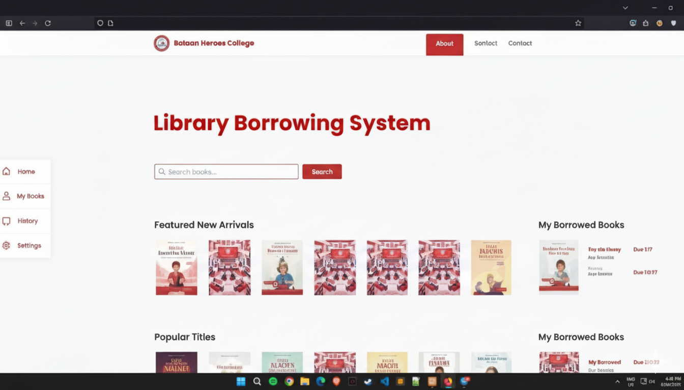

The **Library Borrowing System interface** of *Bataan Heroes College* is designed to be simple, user-friendly, and efficient, allowing students to manage their library activities easily  
  
**Navigation Menu (Left Sidebar)**

* **Home** → Brings the user back to the main dashboard, where featured books and borrowing information are displayed.
* **My Books** → Shows a list of books currently borrowed by the user, including due dates.
* **History** → Displays a record of all previously borrowed books, helping students keep track of their reading and borrowing activity.
* **Settings** → Allows users to update personal details such as password, contact information, or preferences.

**Top Navigation Bar**

* **About** → Provides information about the system and the library services.
* **Contact** → Gives details on how to reach the library (email, phone, office hours).
* **Other Links (e.g., Sonlct)** → May lead to extra features like announcements, policies, or additional services.
* • Search **Bar** → Located at the center, this feature allows students to search for books by title, author, or subject.
* • Featured **New Arrivals** → Displays newly added books to encourage students to explore fresh titles.
* • Popular **Titles** → Highlights frequently borrowed books, helping students discover trending or recommended reads.

**Borrowed Books Section (Right Panel)**

* Shows the student’s currently borrowed books with **due dates clearly indicated** in red.
* Helps students avoid overdue penalties by keeping track of their borrowed items.

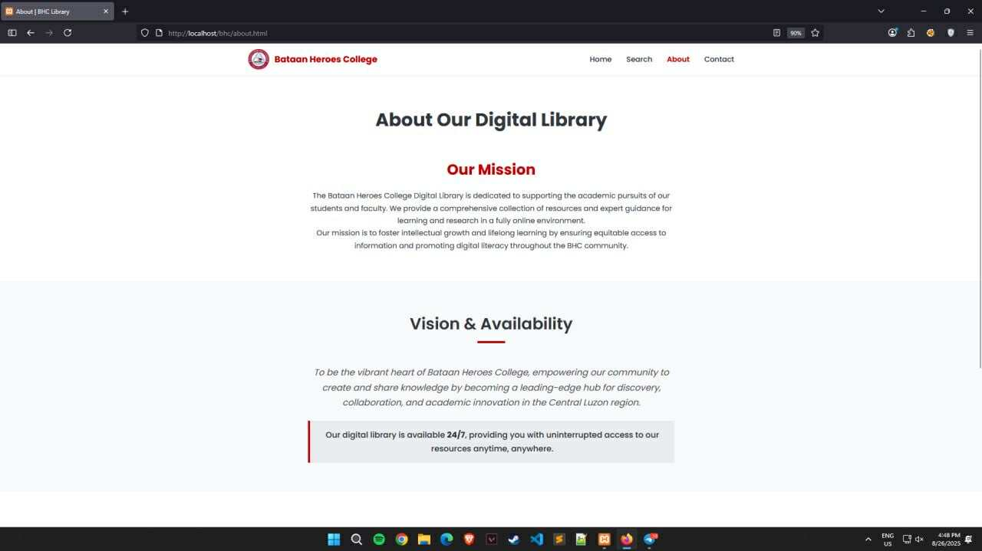

. The **About Page** of the *Bataan Heroes College Digital Library* is designed to introduce users to the purpose, mission, and availability of the library system in a clear and structured way.

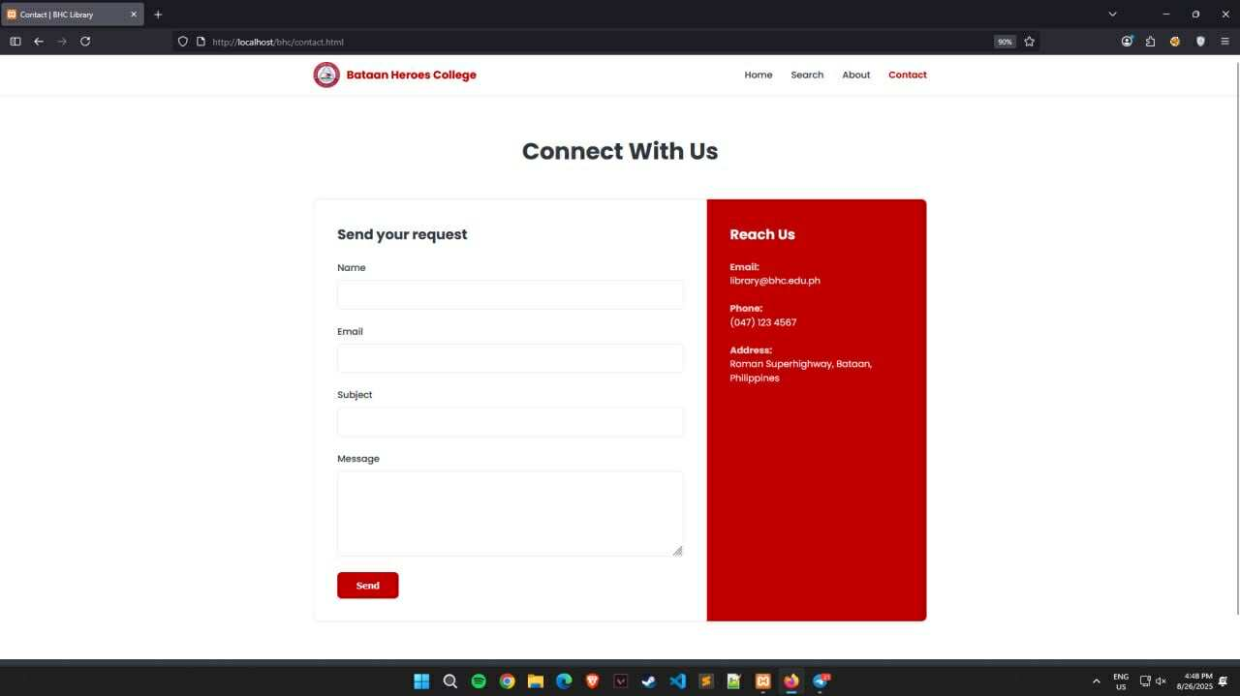

The **Contact Page** of the *Bataan Heroes College Digital Library* provides students, faculty, and visitors with a simple way to reach out to the library staff for inquiries, support, or feedback. The design combines an online form and direct contact details for maximum accessibility.  
  
**. Page Header**

* Displays **“Connect with Us”**, making it clear that this section is meant for communication between users and the library team.

**2. Contact Form (Left Section: “Send your request”)**

* **Name Field** → Users enter their full name for identification.
* **Email Field** → Users provide their email so the library can reply.
* **Subject Field** → Allows users to specify the purpose of their request (e.g., book request, account issue, general inquiry).
* **Message Box** → Users type in their detailed message or concern.
* **Send Button** → Submits the request directly to the library’s system or staff email.

This form provides a **convenient and structured way** for users to communicate without leaving the platform.

**3. Contact Information Panel (Right Section: “Reach Us”)**

* **Email** → Lists the official library email address (library@bhc.edu.ph) for direct inquiries.
* **Phone Number** → Provides a hotline for urgent communication.
* **Physical Address** → Shows the exact location (Roman Superhighway, Bataan, Philippines) for students who may need on-site visits.